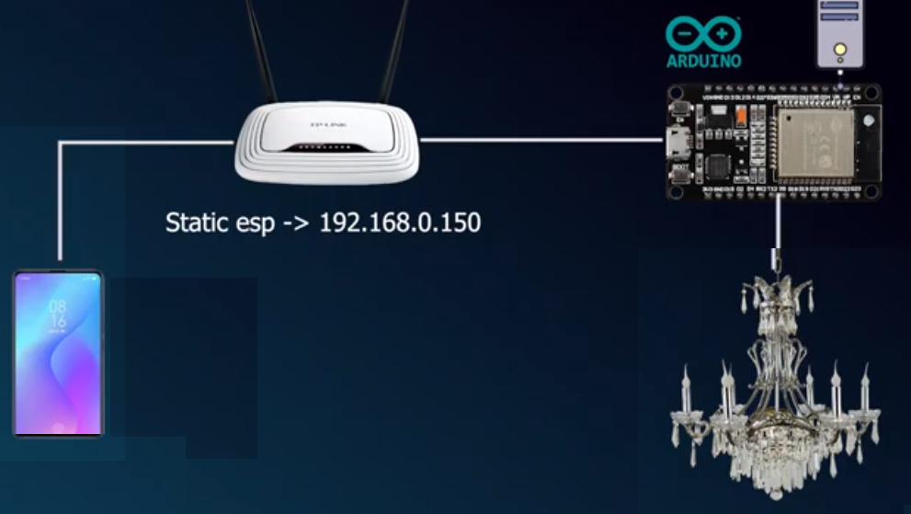

APP INVENTOR

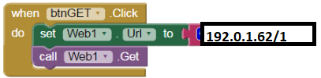

Si recibe “GET HTTP 1” ignora hasta que aparece 1 o 2.

Se simplifica el codigo.

WiFiClient client = server.available();

if (client) {

while (client.connected()) {

if (client.available()) {

char c = client.read();

if (c=="1") digitalWrite(13,HIGH);

if (c=="2") digitalWrite(13,LOW);

}

}

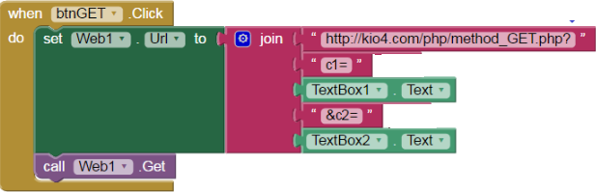

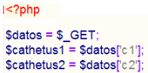

if (header.indexOf("GET /led/on") >= 0) {

if (currentLine.length() == 0) {

client.println("HTTP/1.1 200 OK");

client.println("Content-type:text/html");

client.println("Connection: close");

client.println();

if (header.indexOf("GET /led/on") >= 0) {

ledState = "on";

digitalWrite(led, HIGH);

Serial.println("led on");

}

if (header.indexOf("GET /led/off") >= 0)

{

ledState = "off";

digitalWrite(led, LOW);

Serial.println("led off");

}

// Display the HTML web page

client.println("<!DOCTYPE html><html>");

client.println("**<head></head**><body></body></html>");

} else {

currentLine = "";

}

} else if (c != '\r') {

currentLine += c;

}

}

}

header = "";

client.stop();

Serial.println("Client disconnected.");

Serial.println("");